Q 1 Java program to print welcome message.

**package** assignment;

**class** assignment {

**public** **static** **void** main(String[] args)

{

System.***out***.println("welcome");

}

}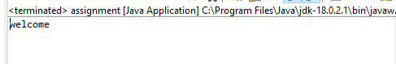

Q 2 Java program to print sum of  three float numbers

**package** assignment;

**class** assignment {

**public** **static** **void** main(String[] args)

{

**float** a=57.0f;

**float** b=69.64f;

**float** c=97.69f;

**float** d=a+b+c;

System.***out***.println("addition of three float no=" + d);

}

}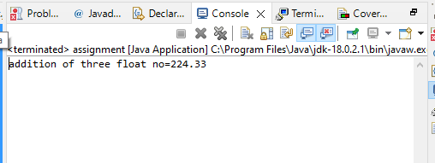

Q 3 Java Program to Swap Two Numbers

**package** assignment;

**import** java.util.Scanner;

**class** assignment {

**public** **static** **void** main(String[] args)

{

Scanner s= **new** Scanner(System.***in***);

System.***out***.println("enter two no");

**int** a=s.nextInt();

**int** b=s.nextInt();

**int** t;

System.***out***.println("no before swapping" + a+" " +b);

t=a+b;

b=t-b;

a=t-b;

System.***out***.println("no after swapping" +a +" " +b);

}

}

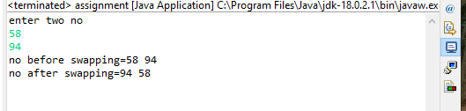

Q 4 Wap to check if number is even or odd

**package** assignment;

**import** java.util.Scanner;

**class** assignment {

**public** **static** **void** main(String[] args)

{

Scanner s= **new** Scanner(System.***in***);

System.***out***.println("enter any no");

**int** a=s.nextInt();

**if**(a%2==0)

System.***out***.println("no is even");

**else**

System.***out***.println("no is odd");

}

}

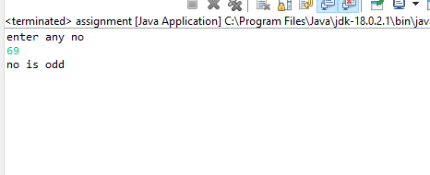

Q 5 wap to check from three given number  that whether a number is greater than or equal to 20 and less than other numbers .print appropriate message .

**package** assignment;

**import** java.util.Scanner;

**class** assignment {

**public** **static** **void** main(String[] args)

{

Scanner s= **new** Scanner(System.***in***);

System.***out***.println("enter first no");

System.***out***.println("enter second no");

System.***out***.println("enter third no");

**int** a=s.nextInt();

**int** b=s.nextInt();

**int** c=s.nextInt();

**if**(a>=20 && a<b && a<c)

System.***out***.println("no greater than 20 and less than other number");

**else**

System.***out***.println("the condion is not true");

}

}

}

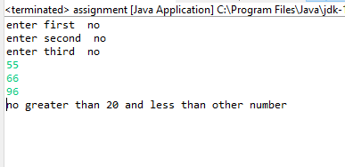

Q 7 wap to check if sales of a person is greater than 10000 then eligible for bonus   
else not eligible calculate bonus as 20% of sales .

**package** assignment;

**import** java.util.Scanner;

**class** assignment {

**public** **static** **void** main(String[] args)

{

**float** sales;

**float** bonus;

Scanner s= **new** Scanner(System.***in***);

System.***out***.println("sales=");

sales=s.nextFloat();

**if**(sales>10000f)

{

System.***out***.println("give bonus");

bonus=0.2f*sales;

System.***out***.println("bonus=" + bonus);

}

**else**

System.***out***.println("no bonus");

}

}

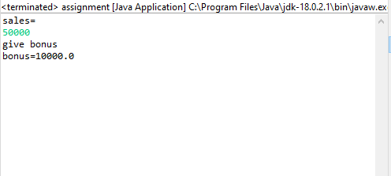

Q 8 wap to check if two given integer value is in range of 18 and 100 print eligible for voting else not eligible .

**package** assignment;

**import** java.util.Scanner;

**class** assignment {

**public** **static** **void** main(String[] args)

{

Scanner s= **new** Scanner(System.***in***);

System.***out***.println("enter first no");

System.***out***.println("enter second no");

**int** a=s.nextInt();

**int** b=s.nextInt();

**if**(a>=18 && a<=100 && b>=18 && b<=100)

System.***out***.println("eligible for voting");

**else**

System.***out***.println("not eligible");

}

}

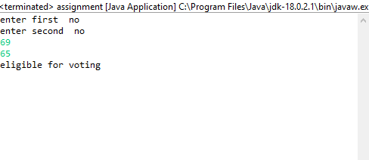

Q 9 wap to print average of  given five subjects marks of student and check if average >=40 print Pass else print fail

**package** assignment;

**import** java.util.Scanner;

**class** assignment {

**public** **static** **void** main(String[] args)

{

Scanner s= **new** Scanner(System.***in***);

System.***out***.println("enter marks of 1st subject=");

System.***out***.println("enter marks of 2nd subject=");

System.***out***.println("enter marks of 3rd subject=");

System.***out***.println("enter marks of 4th subject=");

System.***out***.println("enter marks of 5th subject=");

**int** a=s.nextInt();

**int** b=s.nextInt();

**int** c=s.nextInt();

**int** d=s.nextInt();

**int** e=s.nextInt();

**double** f=(a+b+c+d+e)*0.2;

System.***out***.println("avg of the the student=" + f);

**if**(f>=40)

System.***out***.println("student is pass");

**else**

System.***out***.println("student is failed");

}

}

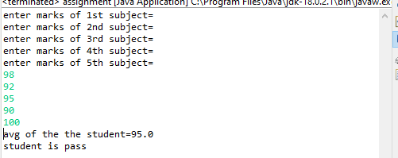

Q10 WAP to ask name ,age and salary of an employee and print on console.

**package** assignment;

**import** java.util.Scanner;

**class** assignment {

**public** **static** **void** main(String[] args)

{

String name;

**int** age;

**double** salary;

Scanner s= **new** Scanner(System.***in***);

System.***out***.println("enter the name of the emplyee");

name=s.next();

System.***out***.println("enter the age of the emplyee");

age=s.nextInt();

System.***out***.println("enter the salary of the employee");

salary=s.nextDouble();

System.***out***.println("enter the name of the employee" + name);

System.***out***.println("enter the age of the employee" + age);

System.***out***.println("enter the salary of the employee" + salary);

}

}

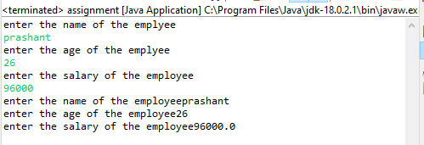

Q 11 wap  that ask two numbers from user and print greater number among two

**package** assignment;

**import** java.util.Scanner;

**class** assignment {

**public** **static** **void** main(String[] args)

{

Scanner s= **new** Scanner(System.***in***);

System.***out***.println("enter 1st number");

**int** a=s.nextInt();

System.***out***.println("enter 2nd number");

**int** b=s.nextInt();

**if**(a>b)

System.***out***.println("a is greter than b");

**else**

System.***out***.println("b is greater than b");

}

}

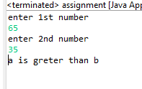

Q 12  wap to ask product name and price of product from user and calculate discount i.e   
if price > 2000 then discount is 10 percent of price   
else discount is 7 % of price

**package** assignment;

**import** java.util.Scanner;

**class** assignment {

**public** **static** **void** main(String[] args)

{

String name;

**double** price;

**double** discount;

Scanner s= **new** Scanner(System.***in***);

System.***out***.println("enter name of the product");

String a=s.next();

System.***out***.println("enter price of product");

**double** b=s.nextDouble();

**if**(b>2000)

{

System.***out***.println("give a discount of 10 percent");

discount=0.1*(b);

System.***out***.println("discount" + discount);

}

**else**

{

System.***out***.println("give a discount of 7 percent");

discount=0.07*(b);

System.***out***.println("discount" + discount);

}

}

}

